**PO4_DGELV_DIGITAL ELEVATOR**

**HSI DOCUMENT**

**Version 1.**1

**Document Status**

|  |  |  |  |  |
| --- | --- | --- | --- | --- |
| **Last Modified** | **Document Name** | **Version** | **Author** | **Status** |
| 1/24/2020 | PO4_DGELV_DIGITALELEVATOR_HSI | 1.0 | Sara Abdallah Ahmed |  |  |
| 1/25/2020 | PO4_DGELV_DIGITALELEVATOR_HSI | 1.1 | Ahmed Omar Zoher |  |
| 2/2/2020 | PO4_DGELV_DIGITALELEVATOR_HSI | 1.2 | Sara Abdallah Ahmed | Proposed |

**Revision History**

|  |  |  |  |  |
| --- | --- | --- | --- | --- |
| **Date** | **Version** | **Description** | **Author** | **status** |
| 1/24/2020 | 1.0 | Initial Draft, specifying used hardware. | Sara Abdallah Ahmed Youssif | draft |
| 1/25/2020 | 1.1 | Review | Ahmed Omar Zoher | proposed |
| 2/2/2020 | 1.2 | Review | Sara Abdallah Ahmed | proposed |

**Reference Documents**

|  |  |  |
| --- | --- | --- |
| **Document Name** | **Version** | **Author** |
| PO4_DGELV_DIGITALELEVATOR_CYRS | 1.3 | Sara Abdallah Ahmed |

**Table of Contents**

Table of Contents

1 Introduction 4

1.2 Specification Objectives 4

2 System Overview: 5

2.1 Definition: 5

2.2 Block Diagram: 5

2.3 Hardware Requirement 6

3. Hardware connection: 7

# 1 Introduction

This section introduces the Hardware Software Interface (HSI) for a digital Elevator with lock system and specify the hardware used in the system.

## 1.2 Specification Objectives

The objectives of this specification are to:

* Provide a Hardware system design system overview for the digital Elevator with lock system

# 2 System Overview:

## 2.1 Definition:

The digital Elevator has lock system for 10 users that can be configured and edited by the user with high security sequence to ensure that only approved users can use the elevator.

## 2.2 Block Diagram:

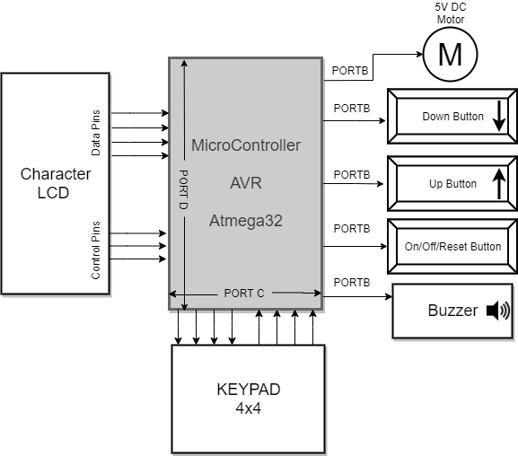

## 2.3 Hardware Requirement

|  |  |  |
| --- | --- | --- |
| **Feature** | **REQ_ID** | **Used Hardware** |
| **Microcontroller** | REQ_ PO4_DGELV _HSI_01_V1_1 | The system will be controlled using AVR microcontroller Atmega32. |
| **Simulation Model** | REQ_ PO4_DGELV _HSI_02_V1_1 | The system will have 5v DC motor to Indicate the movement of the elevator clock wise direction for moving up and anti-clock wise for moving down. |
| **elevator direction selection** | REQ_ PO4_DGELV _HSI_03_V1 | The system will have two push buttons to select direction up and down. |
| **System on, off and reset.** | REQ_ PO4_DGELV _HSI_04_V1_1 | The system will have one push button for both on and off mode, in addition to a reset mode upon holding the same button for 2 seconds . |
| **Screen for displaying data** | REQ_ PO4_DGELV _HSI_05_V1 | The system will have LCD screen CLCD (Character Liquid Crystal Diodes) That will show the user name and password. |
| **Alarm subsystem** | REQ_ PO4_DGELV _HSI_06_V1 | The system will use buzzer to indicate for wrong password after three trial. |
| **Display Login Status** | REQ_ PO4_DGELV _HSI_07_V1_1 | The system will Display OK upon successful login, while NOK upon unsuccessful one. |
| **Username and password input hardware** | REQ_ PO4_DGELV _HSI_08_V1_1 | The system will have keypad to enter a username and a password. |

# 3. Hardware connection:

|  |  |  |
| --- | --- | --- |
| **Feature** | **REQ_ID** | **Description** |
| **AVR**  **Atmega32** | REQ_ PO4_DGELV _HSI_01_V1 | * AVR have four PORTS and every PORT has eight pin DIO. |
| **5v DC Motor** | REQ_ PO4_DGELV _HSI_02_V1 | * The DC motor will connect to PORTB and use one pin.   **#output Pins** |
| **Up/down push buttons** | REQ_ PO4_DGELV _HSI_03_V1 | * The two push buttons will connect to PORTB and use two pins.   **#input Pin** |
| **ON/OFF/Reset push button** | REQ_ PO4_DGELV _HSI_04_V1_1 | * The push button will connect to PORTB and use one pin.   **#input Pins** |
| **CLCD** | REQ_ PO4_DGELV _HSI_05_V1 | * CLCD will connected PORTD and use four pin for sending data and three pin for controlling the data.   **#output Pins** |
| **Buzzer** | REQ_ PO4_DGELV _HSI_06_V1 | * Buzzer will connect to PORTB and use one pin.   **#output Pins** |
| **KEYPAD** | REQ_ PO4_DGELV _HSI_08_V1 | * The KEYPD 4*4 will connect to PORTC four pins as input and four pins as output. * The keypad has 16 buttons, the first 10 buttons is for entering number from 0-9 and the other 6 buttons for entering the alphabetic characters every button from those six bottoms represent from 4-5 character and by pressing the button you can change the characters.   **#input and output Pins** |